### **1. Building a Serverless Web Application**

**Objective**: Create a serverless web application using AWS Lambda, API Gateway, S3, and DynamoDB.

**Approach**:

* **Set Up Backend**: Create Lambda functions to handle backend logic. These functions will interact with a DynamoDB table for data storage.
* **API Gateway**: Set up API Gateway to create RESTful endpoints that trigger the Lambda functions.
* **Frontend Hosting**: Host a static website on S3 that interacts with the backend via API Gateway.
* **Integration**: Ensure that the frontend can successfully send requests to the backend and display responses.

**Goal**: Understand the basics of building and connecting serverless backend services with a static frontend, enabling a fully serverless web application.

### 1)crate s3 bucket and upload all front end related files.

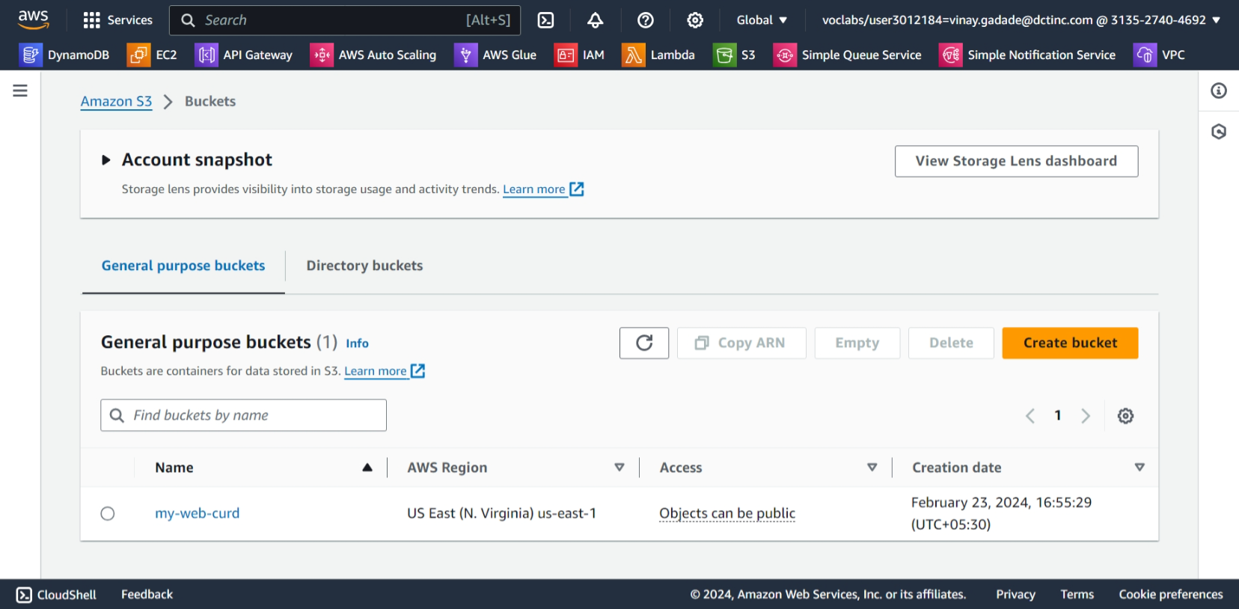

Set all permissions and properties and set bucket policies.

{  
    "Version": "2012-10-17",  
    "Statement": [  
        {  
            "Sid": "AllowGetObject",  
            "Effect": "Allow",  
            "Principal": "*",  
            "Action": "s3:GetObject",  
            "Resource": "arn:aws:s3:::my-web-curd/*"  
        }  
    ]  
}

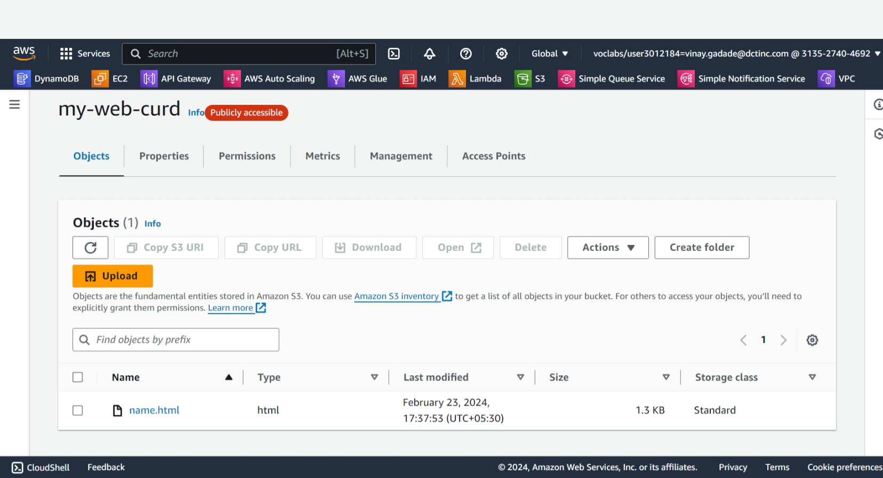

**Create a DynamoDB Table**: Go to the AWS Management Console, navigate to DynamoDB, and create a new table with a primary key (e.g., "id").

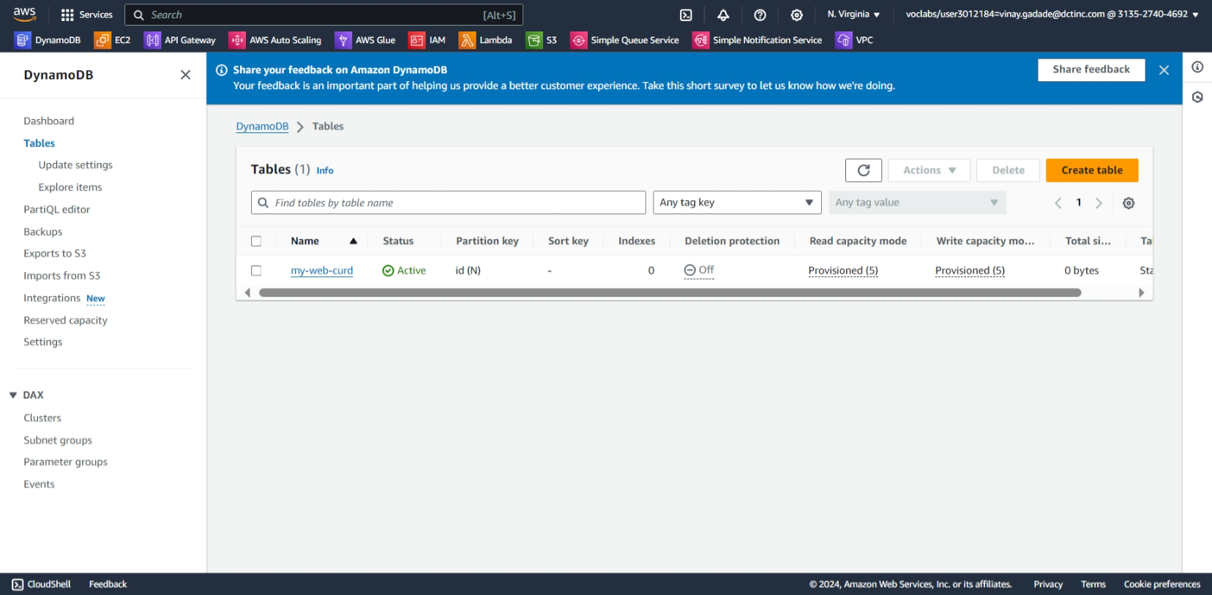

**Write Lambda Functions:** Use the AWS SDK (e.g., boto3 for Python) to write Lambda functions that interact with the DynamoDB table. For example, you can create functions for CRUD operations (Create, Read, Update, Delete).

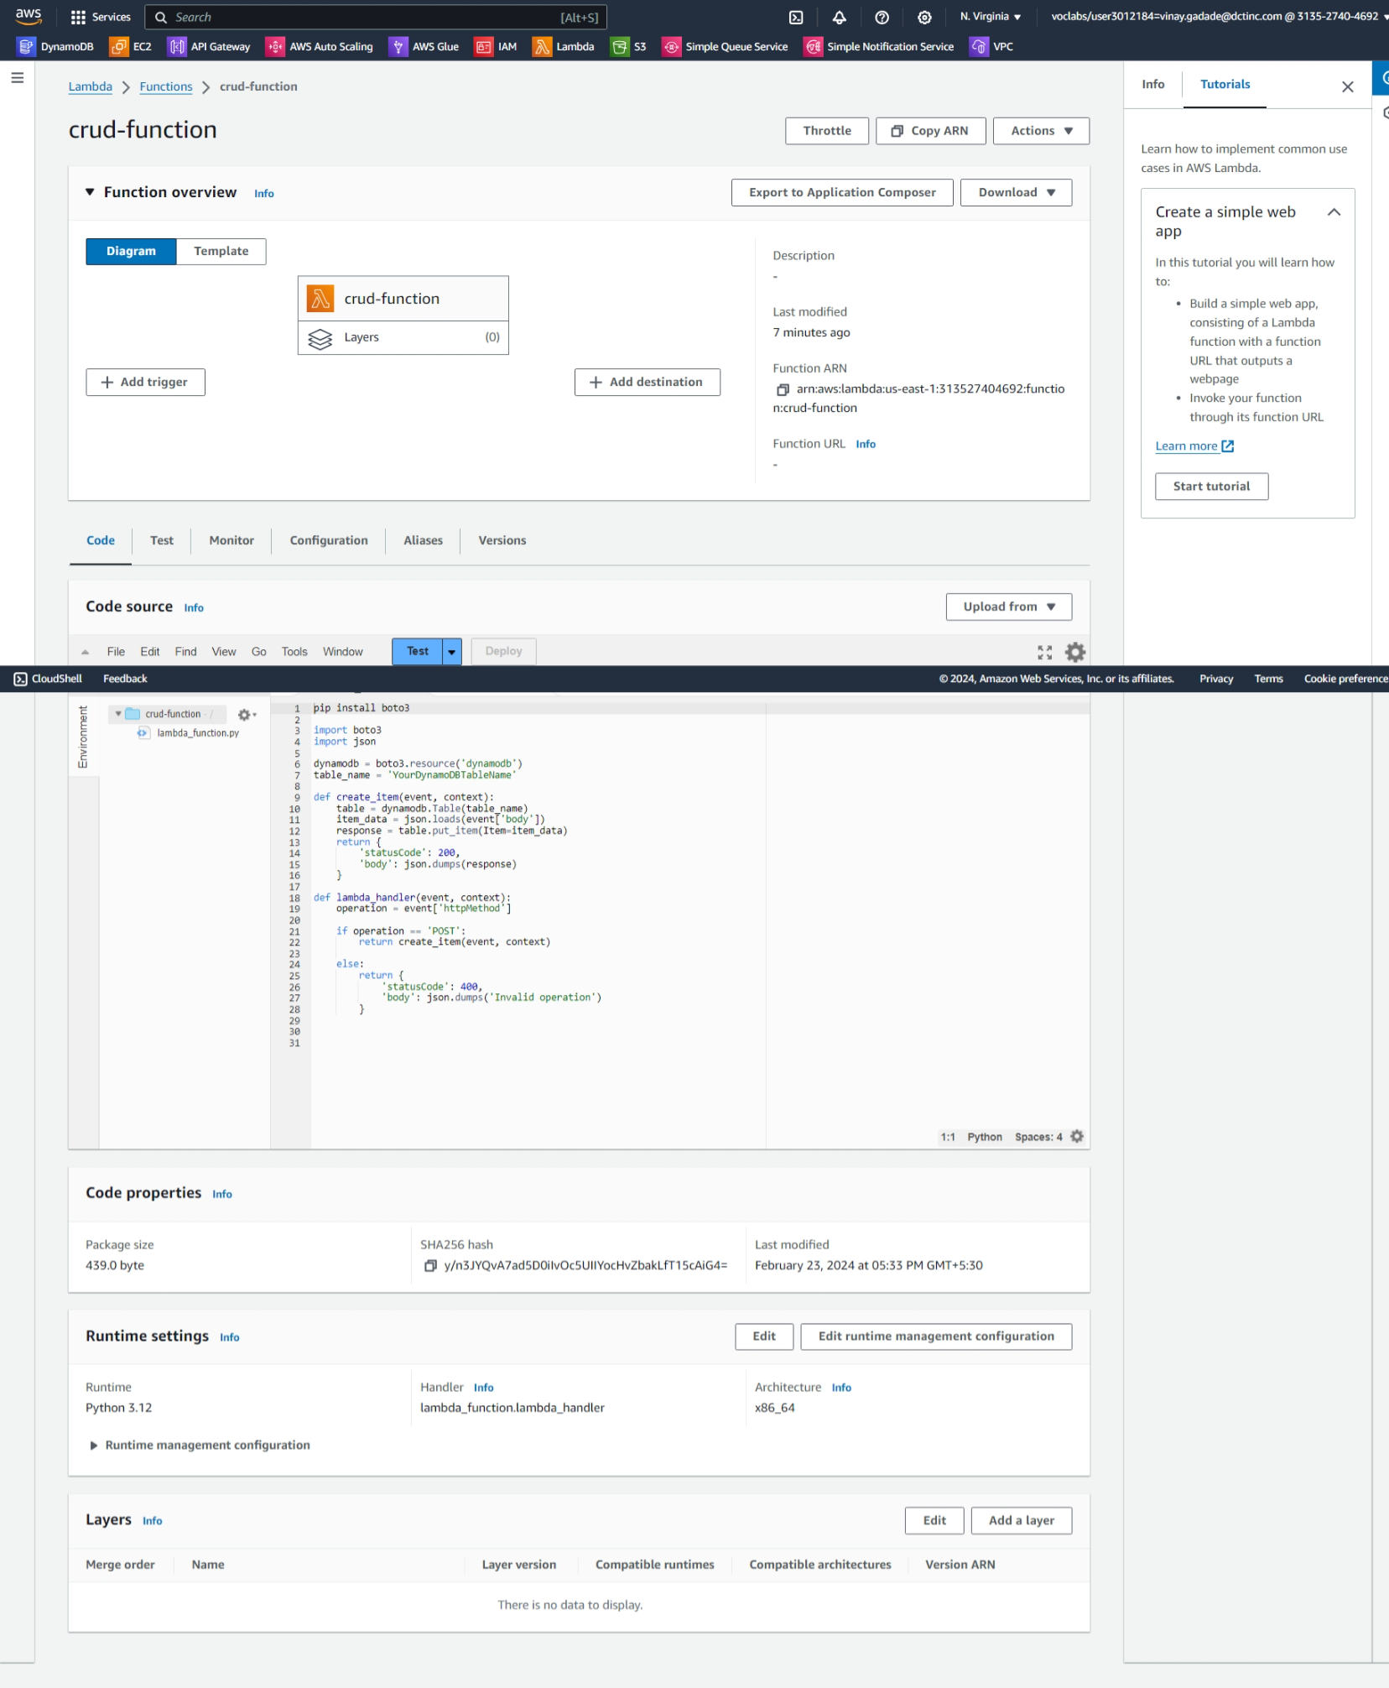

**Create RESTful Endpoints**: In the API Gateway console, create API endpoints that trigger your Lambda functions. Define the HTTP method (POST) for each endpoint.

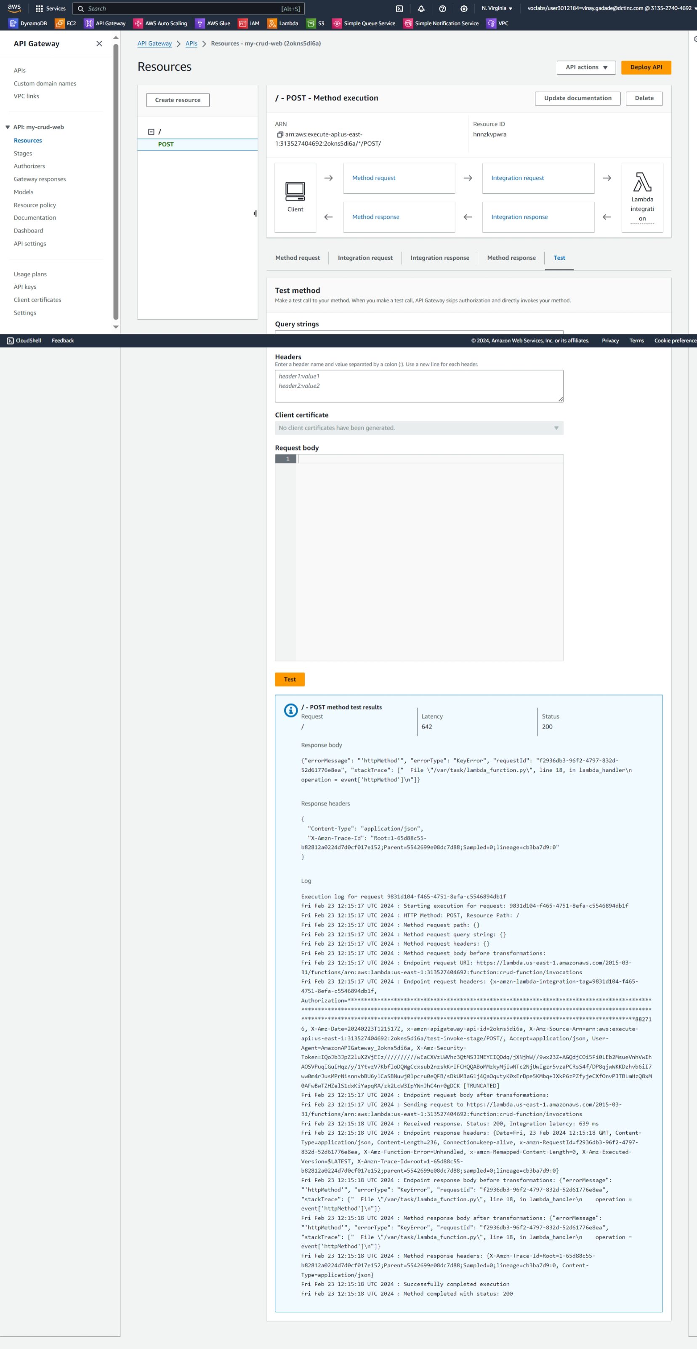

* **Configure CORS in API Gateway:**

1. Go to the API Gateway console.
2. Select your API.
3. In the API Gateway console, choose your API and select the "Enable CORS" action from the "Actions" dropdown menu.
4. Configure CORS settings by adding the allowed origin (e.g., the URL of your S3 frontend), methods, headers, and other settings as needed. For example, you might set the allowed origin to https://your-s3-bucket-url.s3.amazonaws.com and allow GET, POST, PUT, DELETE methods.

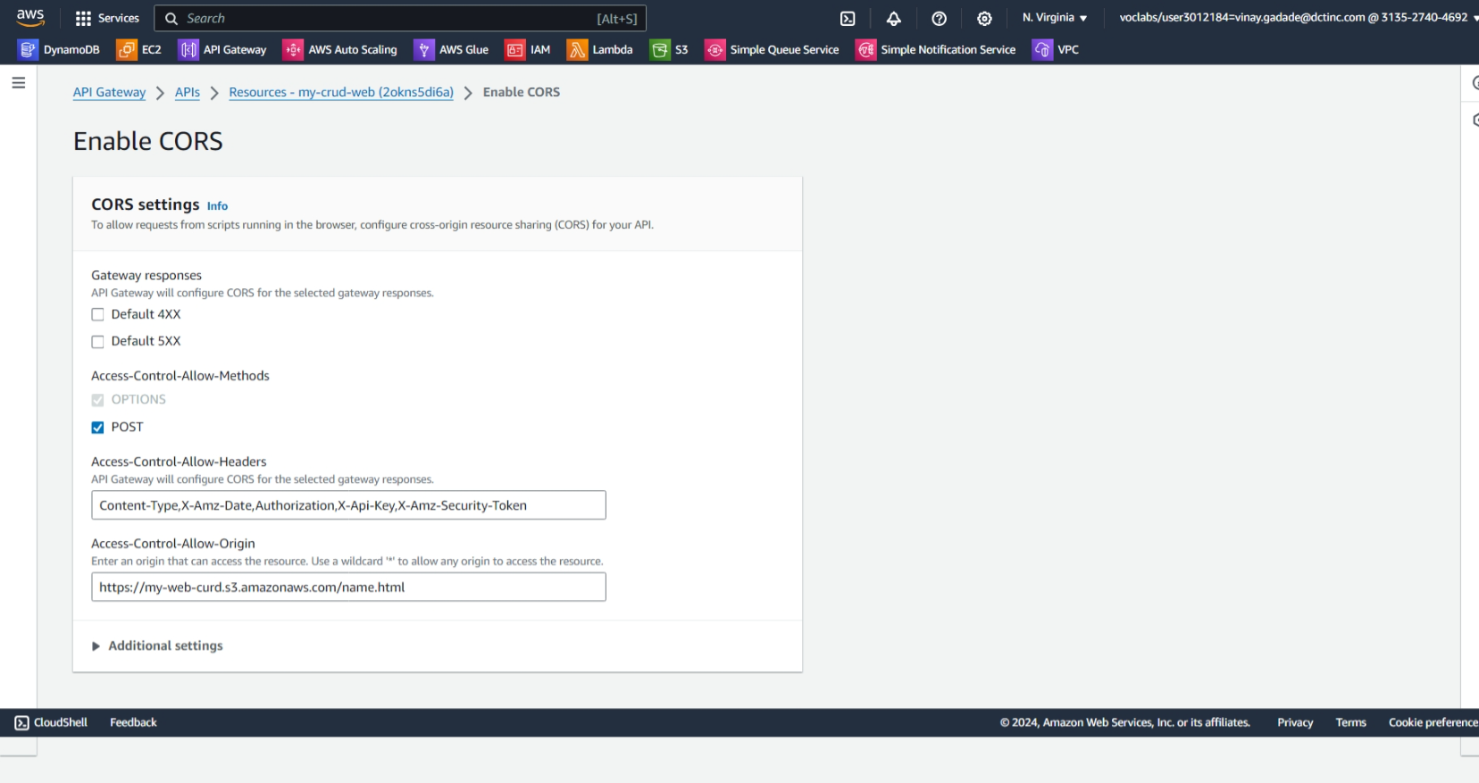

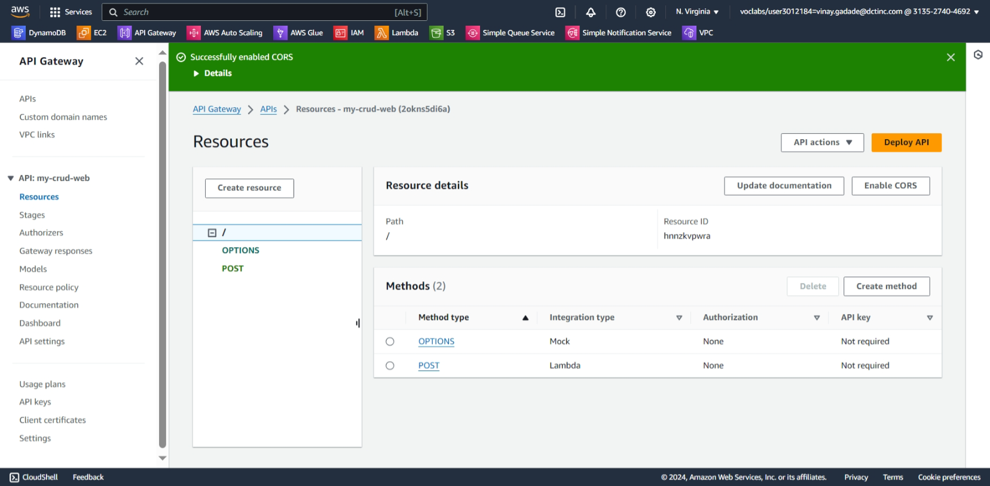

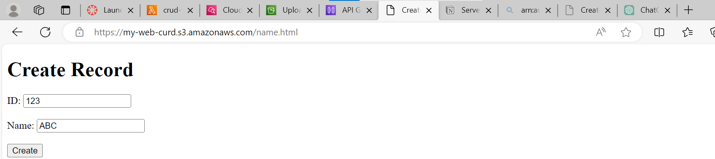

File get uploaded

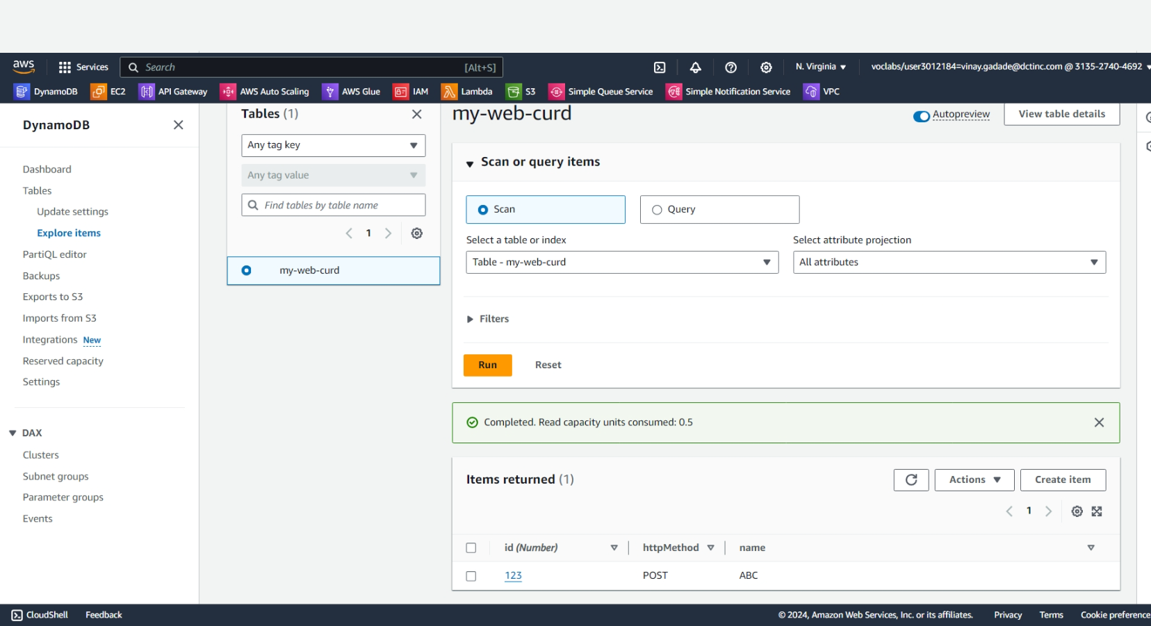

### 2**. Creating a Serverless API**

**Objective**: Develop a serverless API using AWS Lambda and API Gateway.

**Approach**:

* **Define API**: Design a simple RESTful API (e.g., for a todo list application).
* **Lambda Functions**: Create Lambda functions for each API method (GET, POST, PUT, DELETE).
* **API Gateway Setup**: Use API Gateway to set up the API endpoints, connecting each endpoint to the corresponding Lambda function.
* **Testing**: Test the API using tools like Postman or AWS API Gateway test functionality.

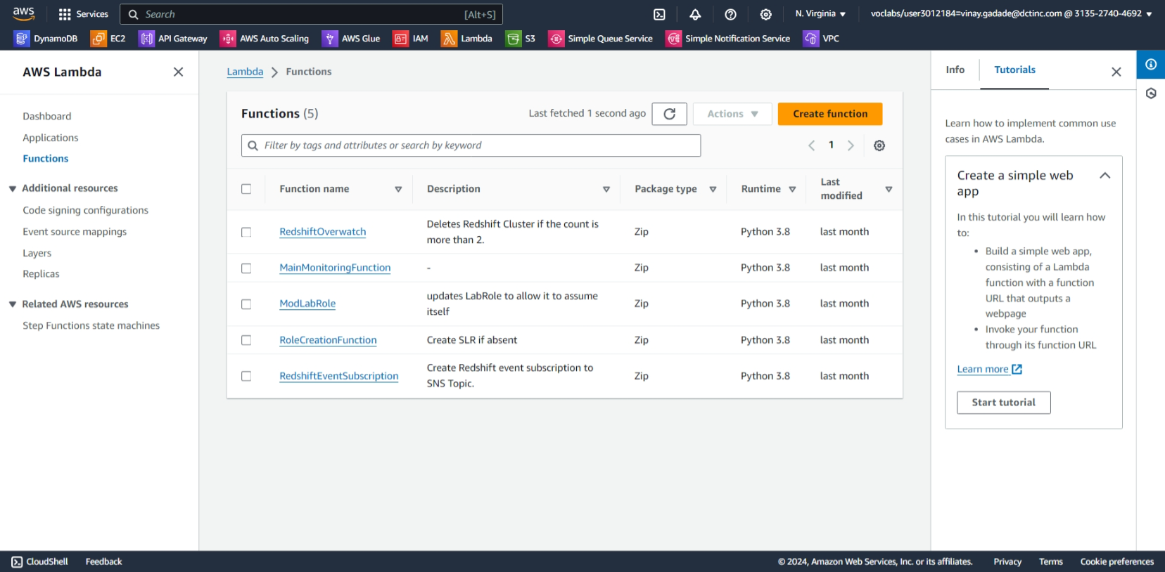

**Create 4 fuctions with name get ,put ,delete ,post with permission use and existing role {“lab-role”}**

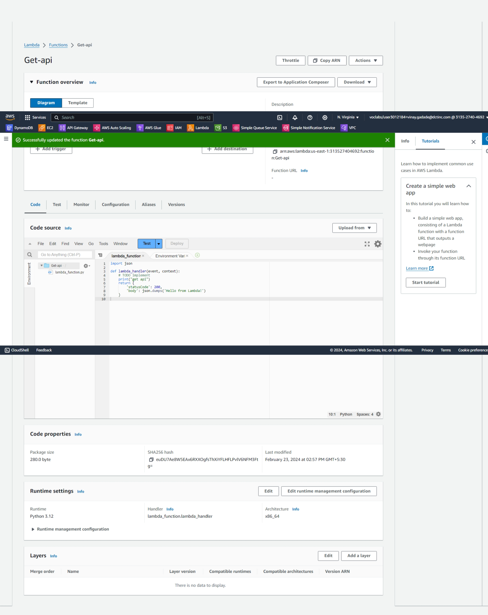

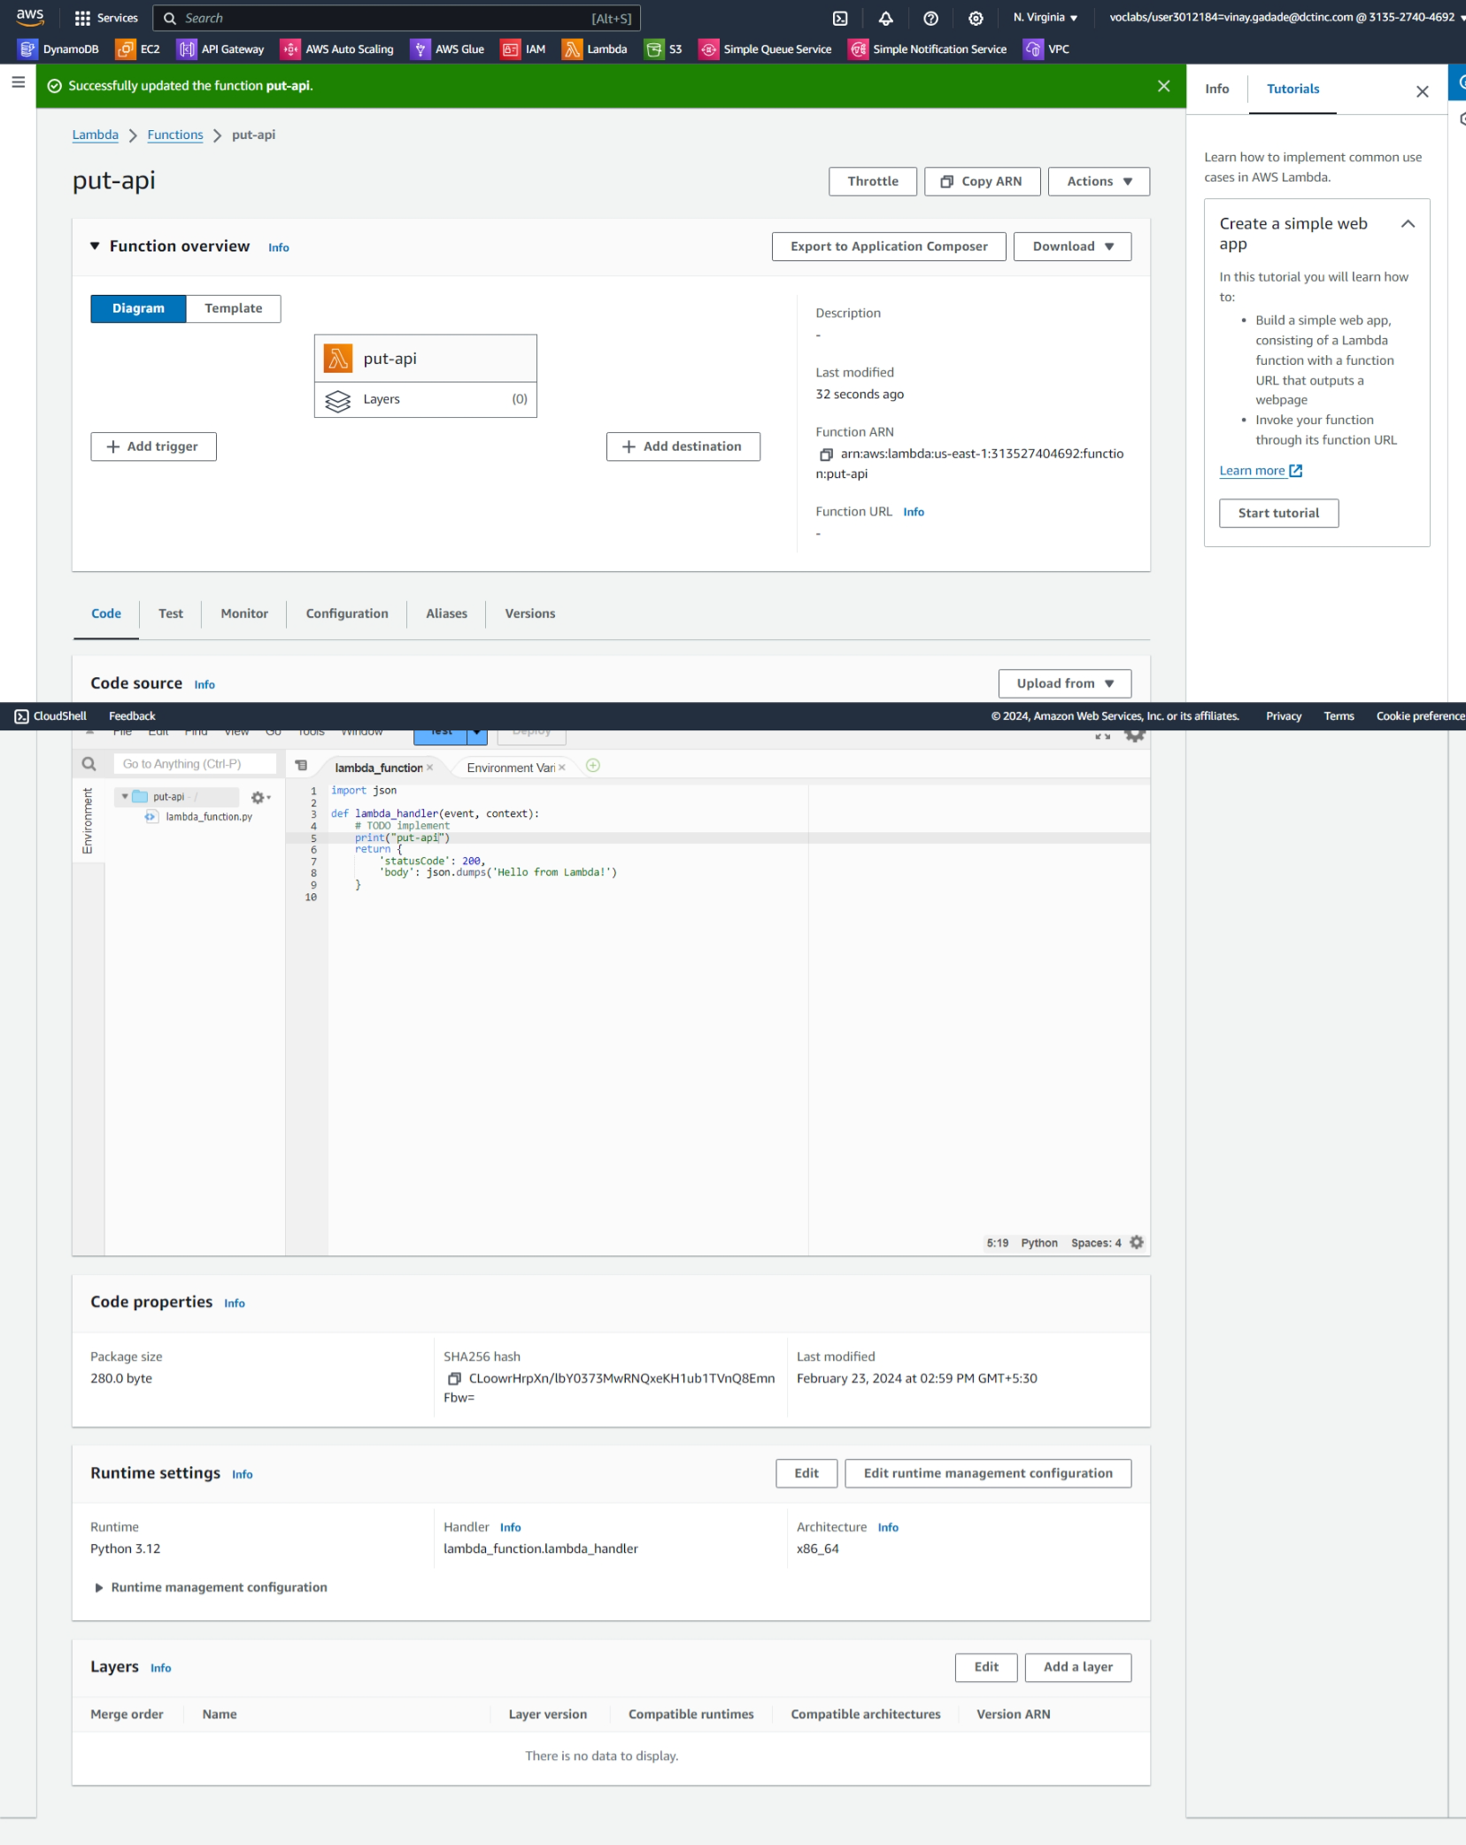

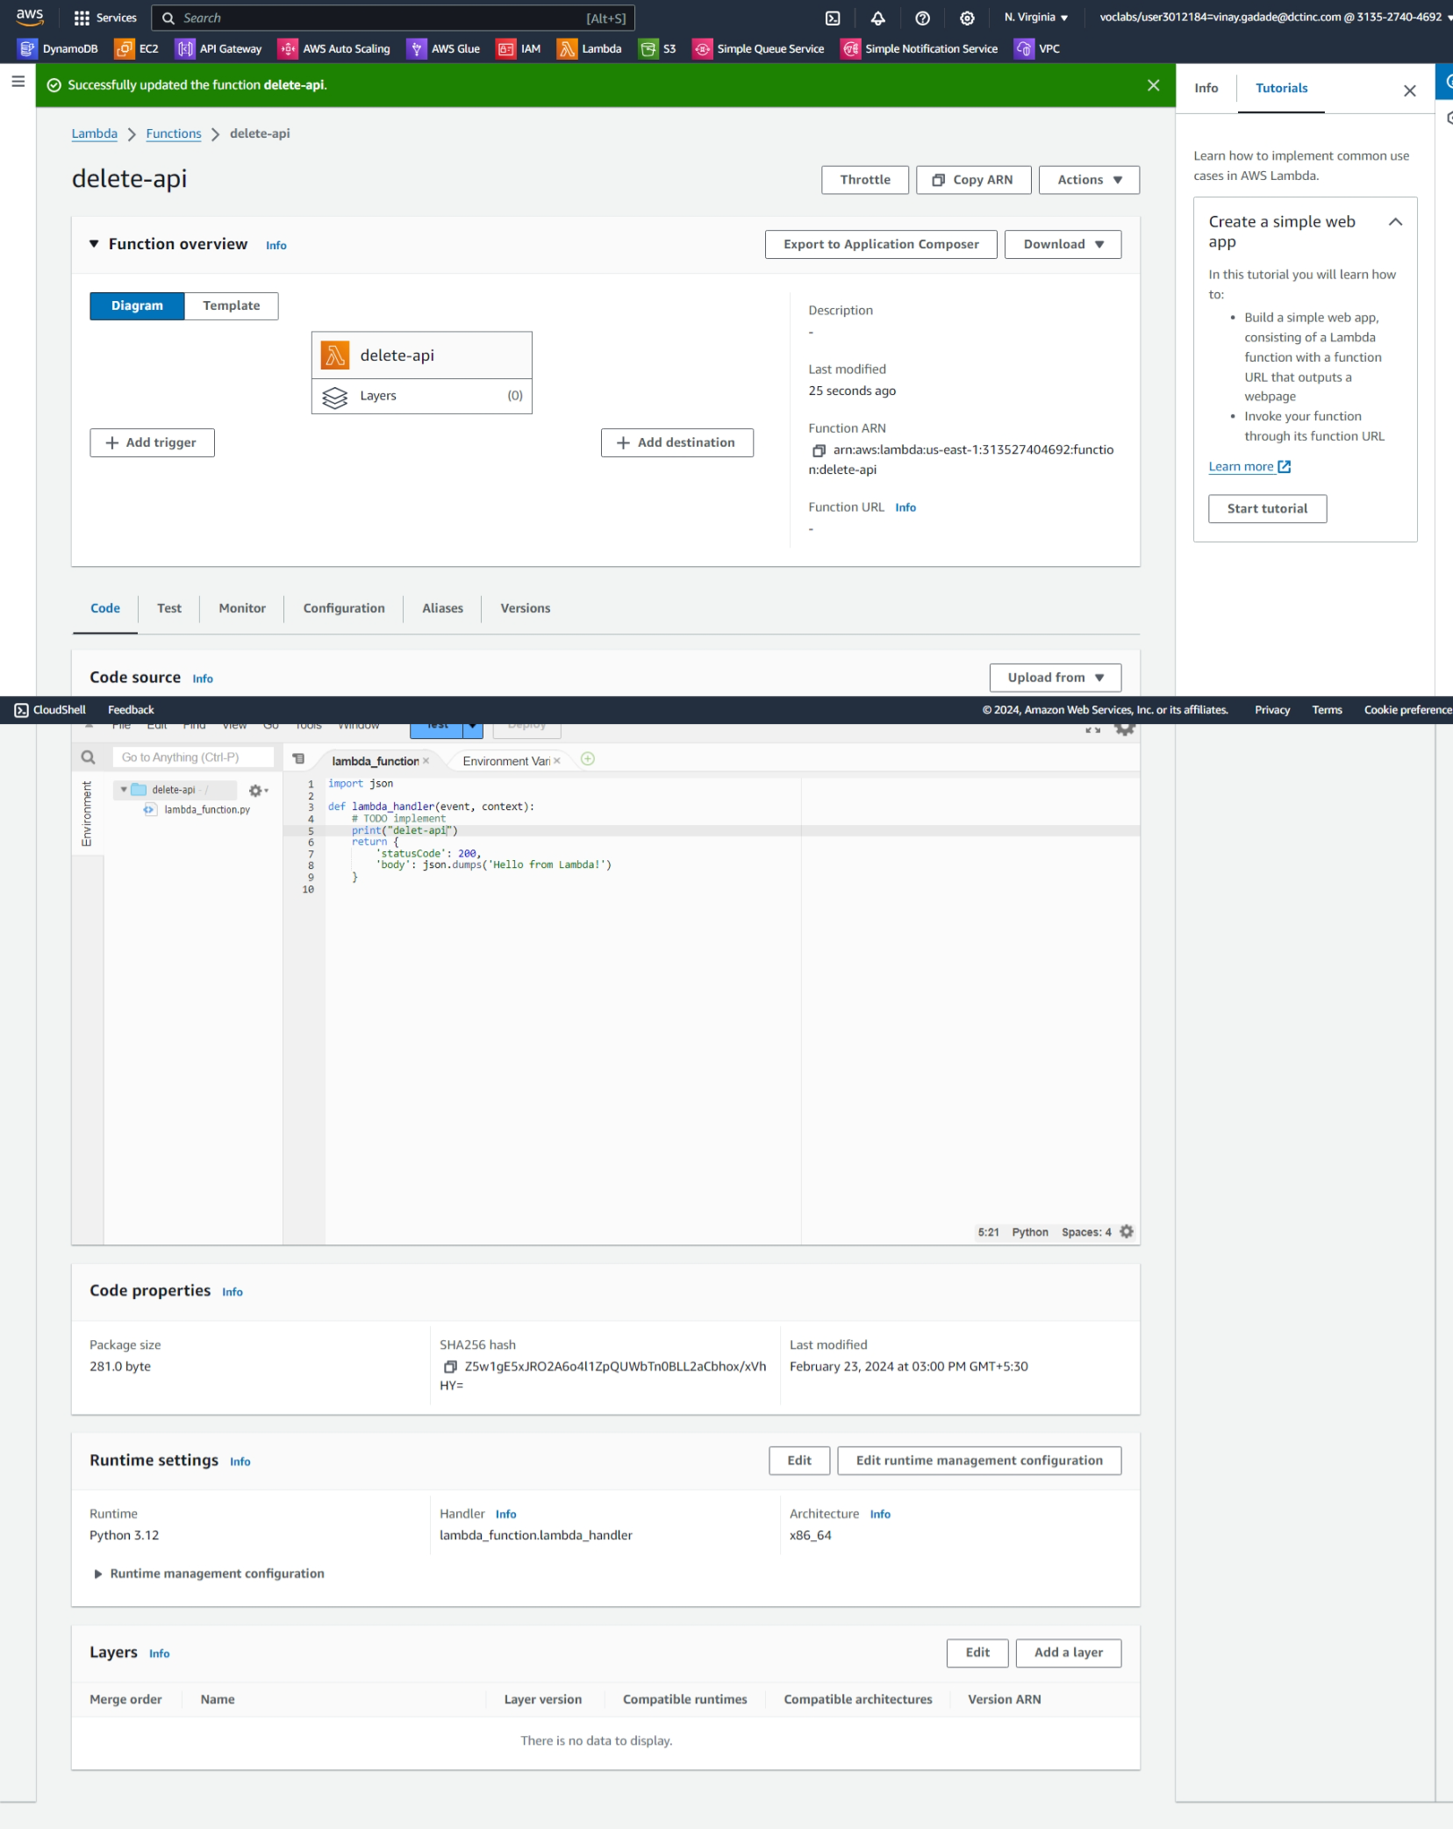

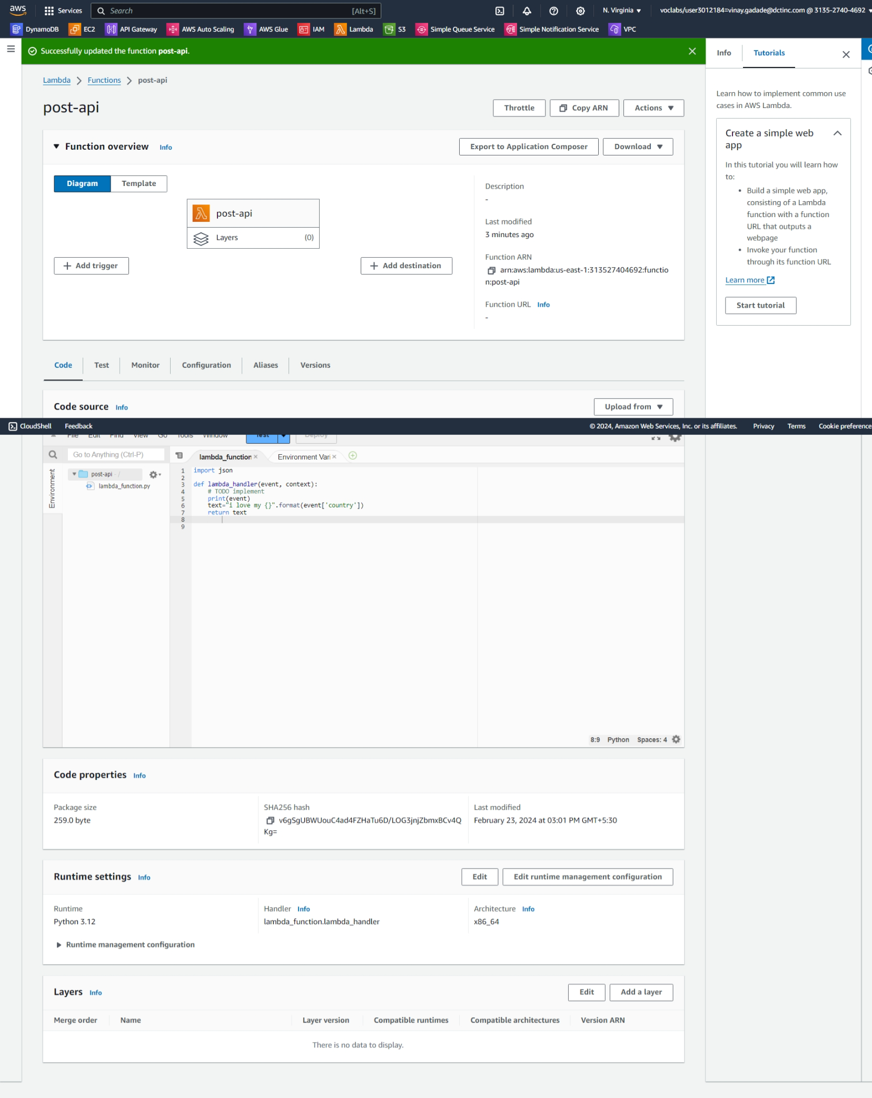

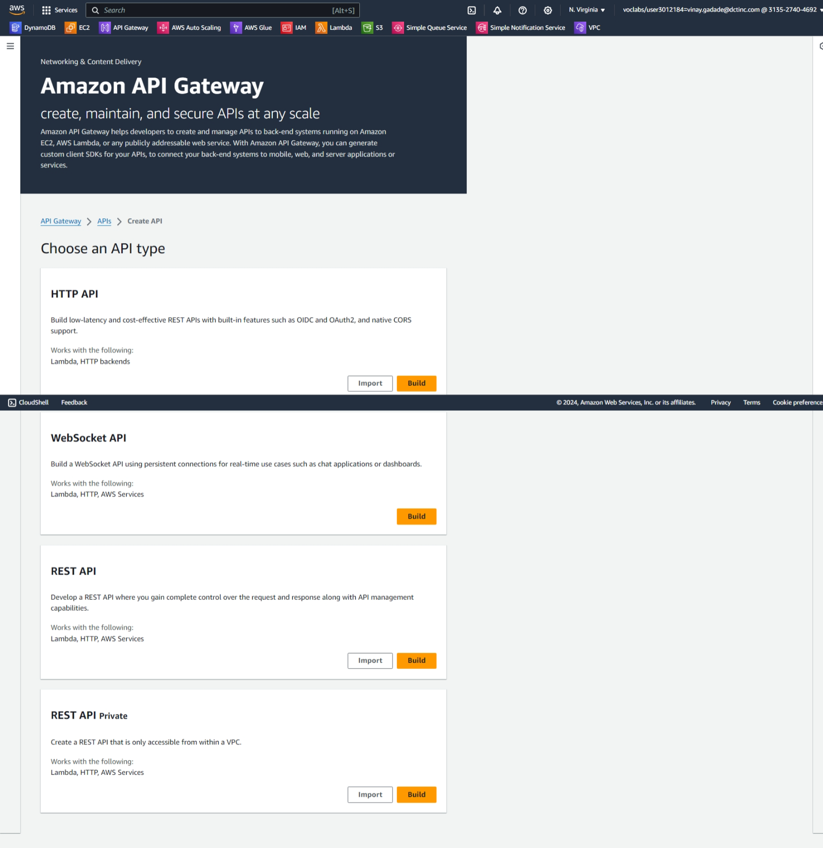

**Create 4 methods with get, post,put,delete**

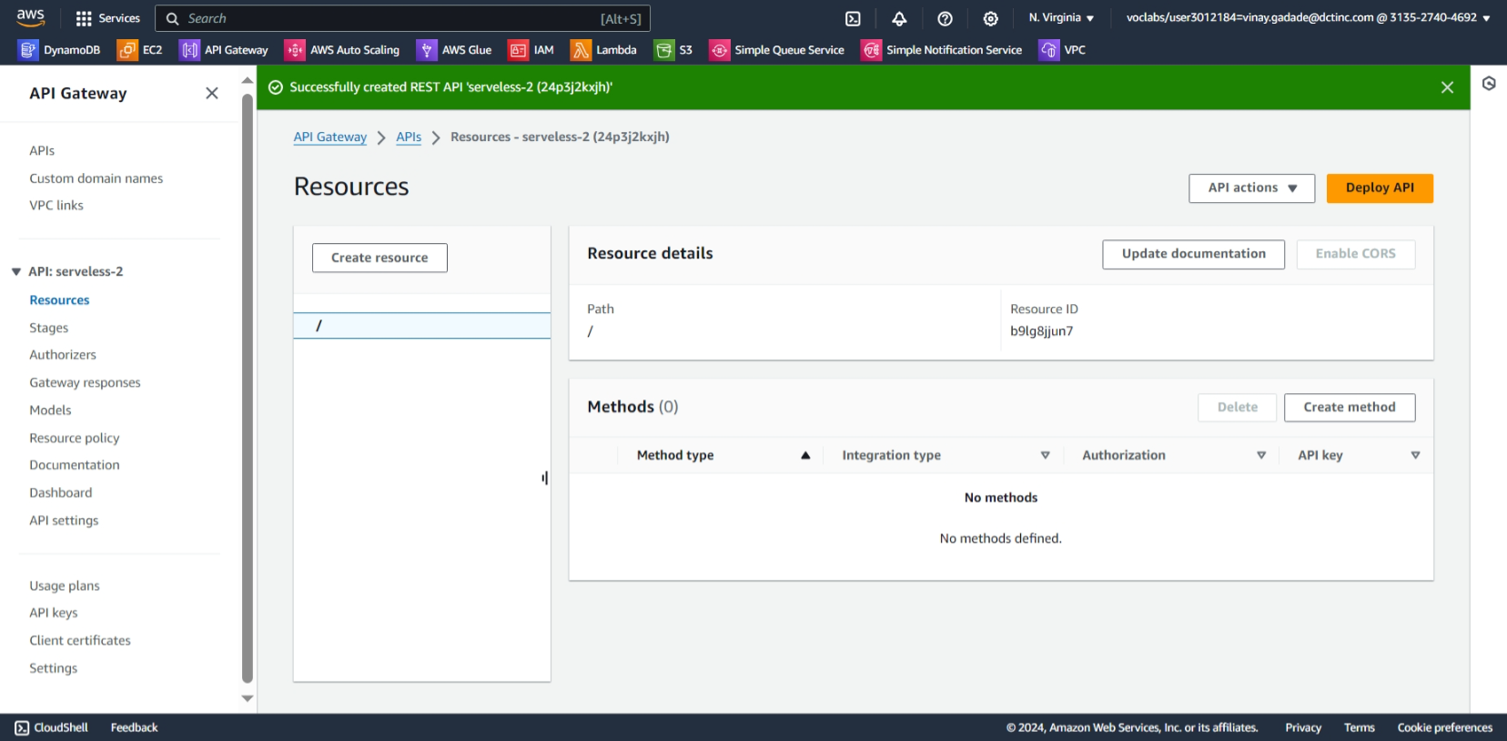

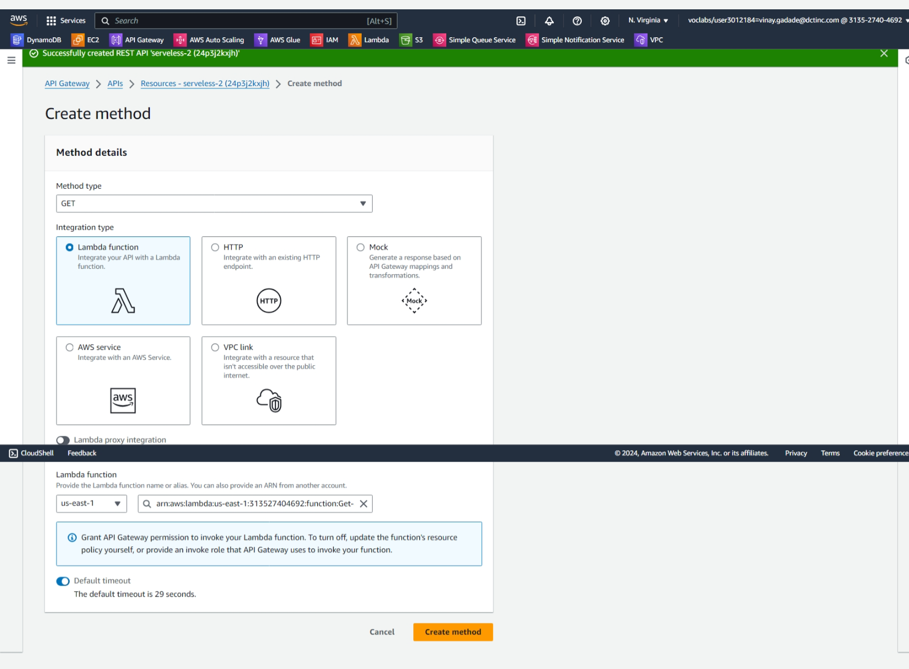

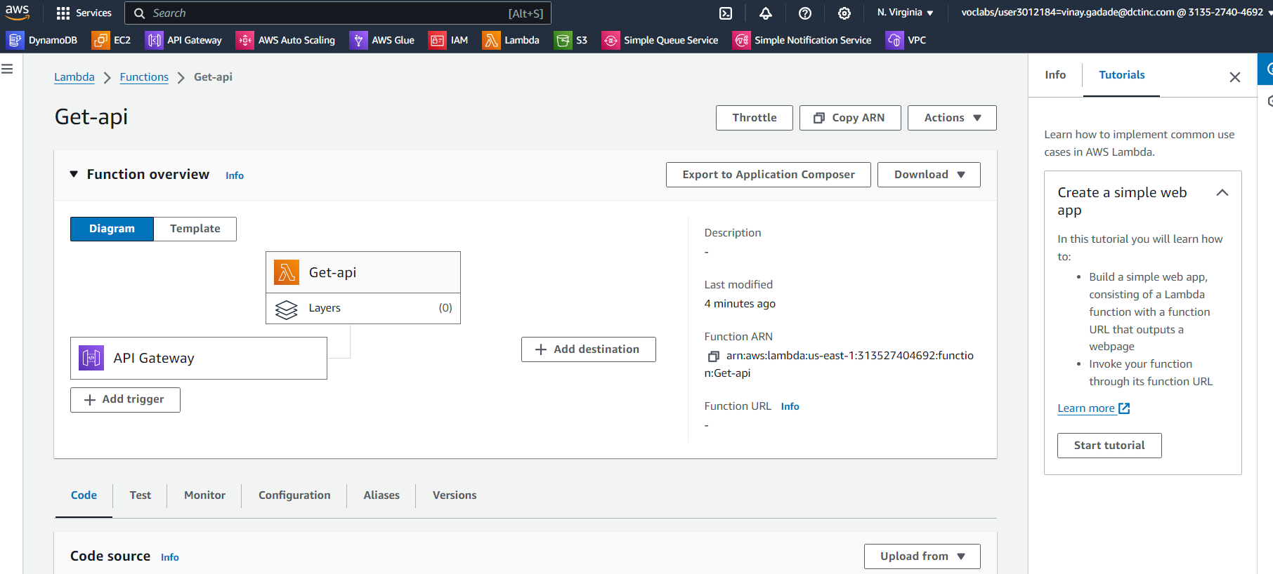

**Testing get-api do same for all api**

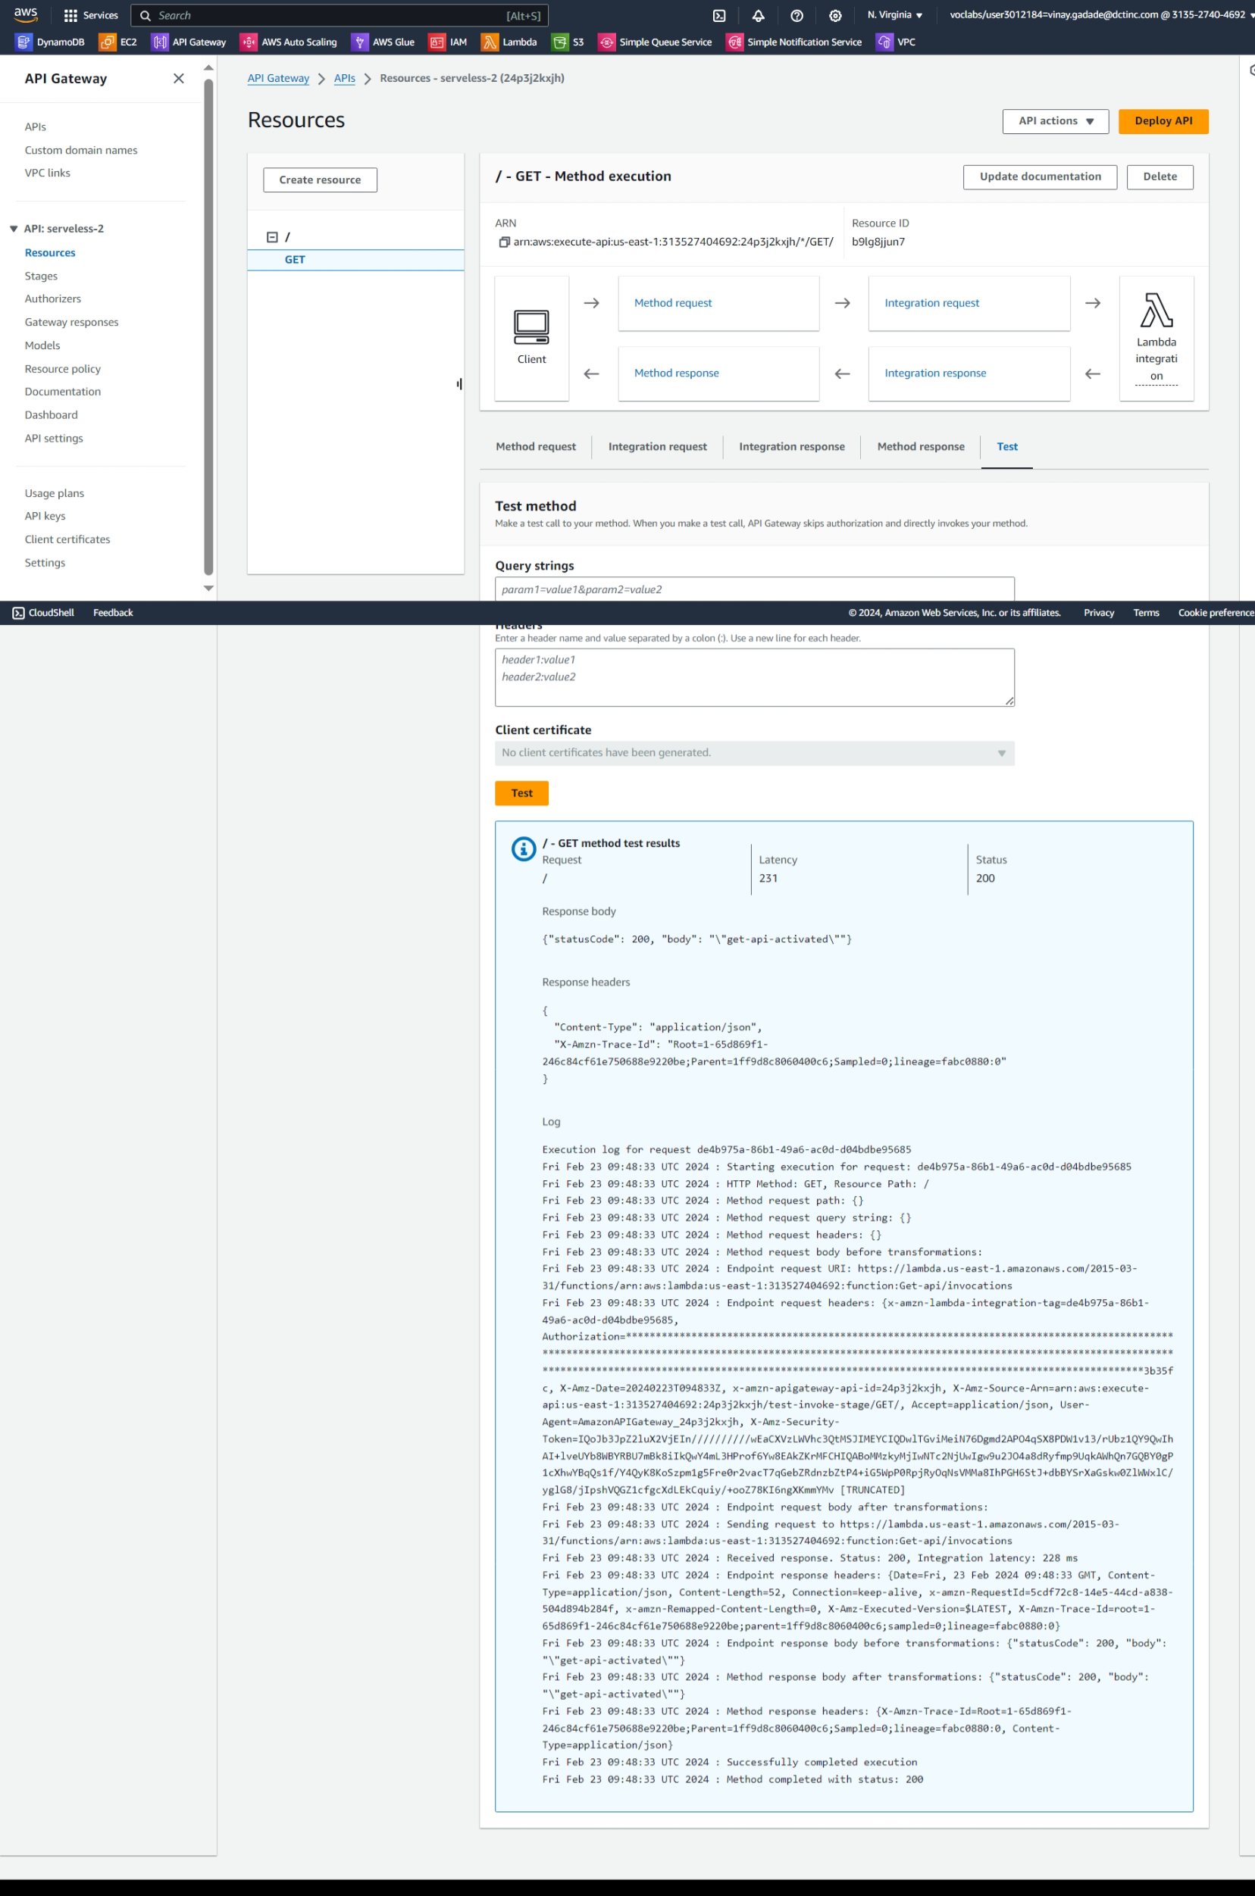



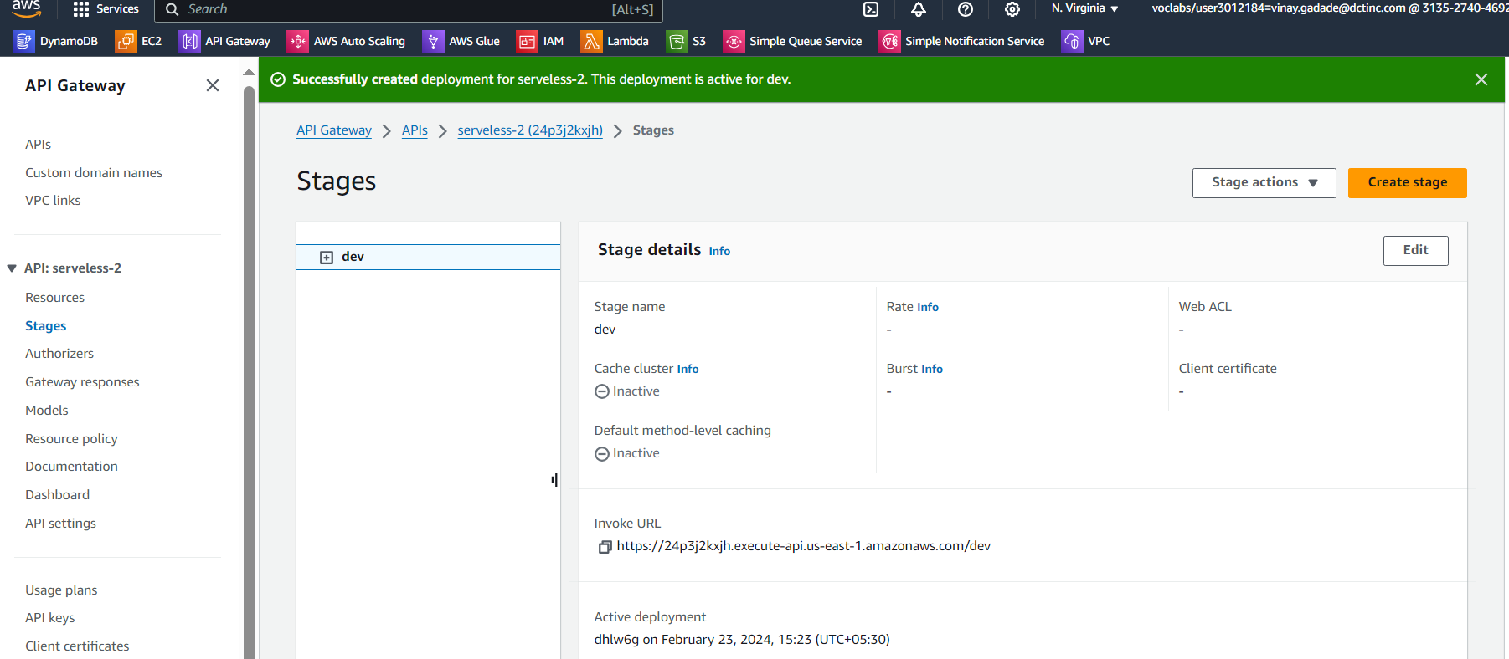

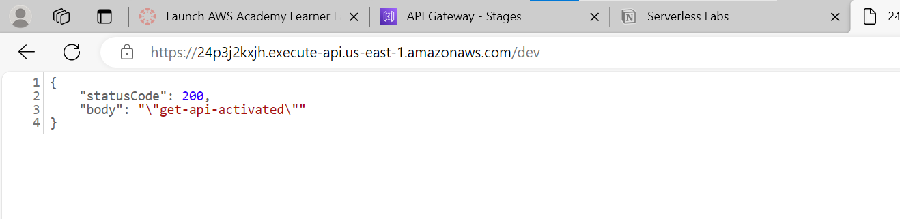

**Follow same process for all 4 functions**

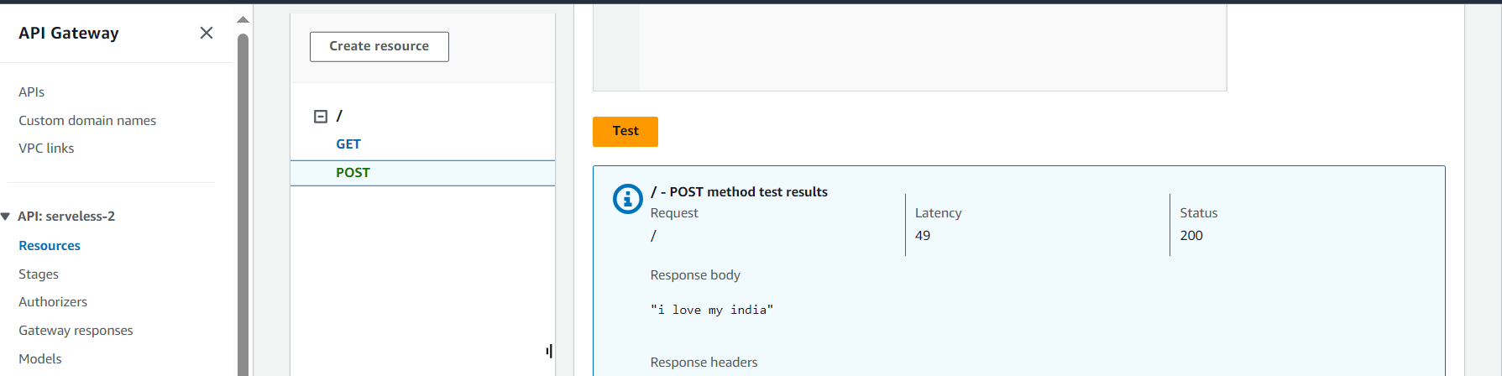

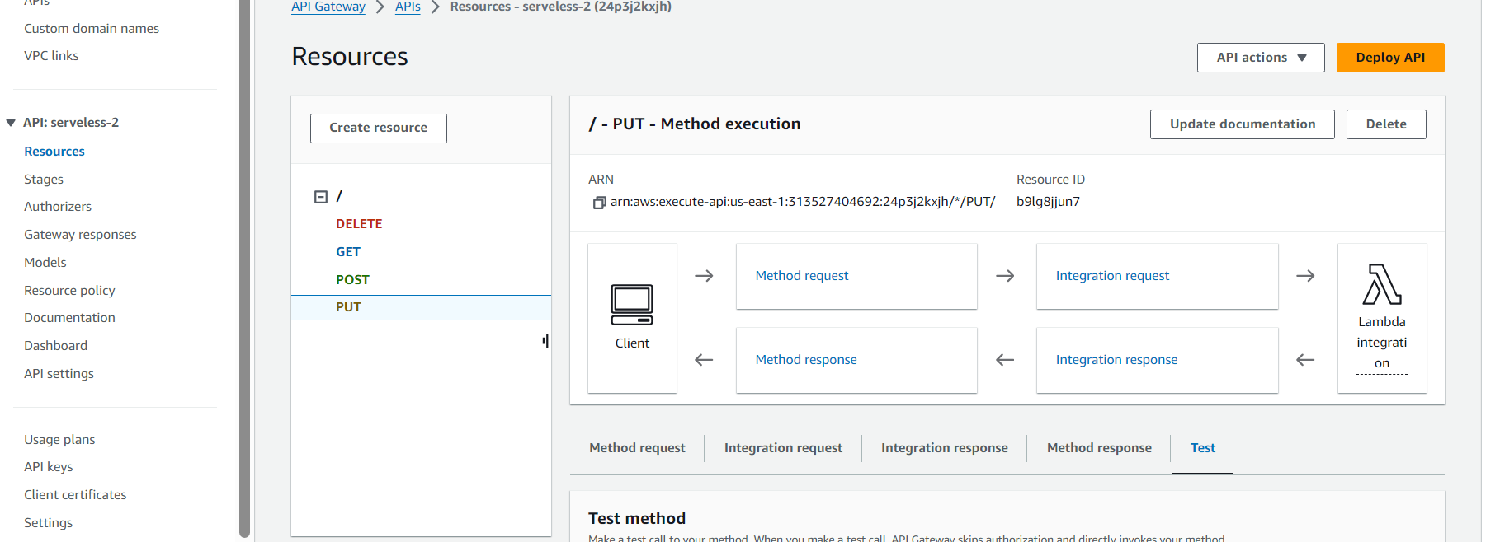

**Serverless Data Processing Pipeline**

Build a serverless pipeline for processing data (e.g., log processing or ETL jobs).

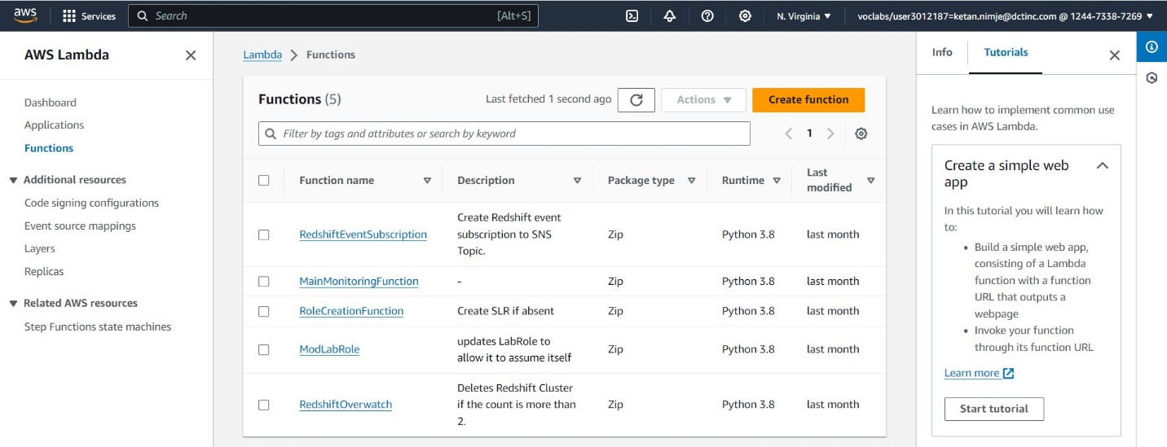

Creating a lambda function- demo lambda

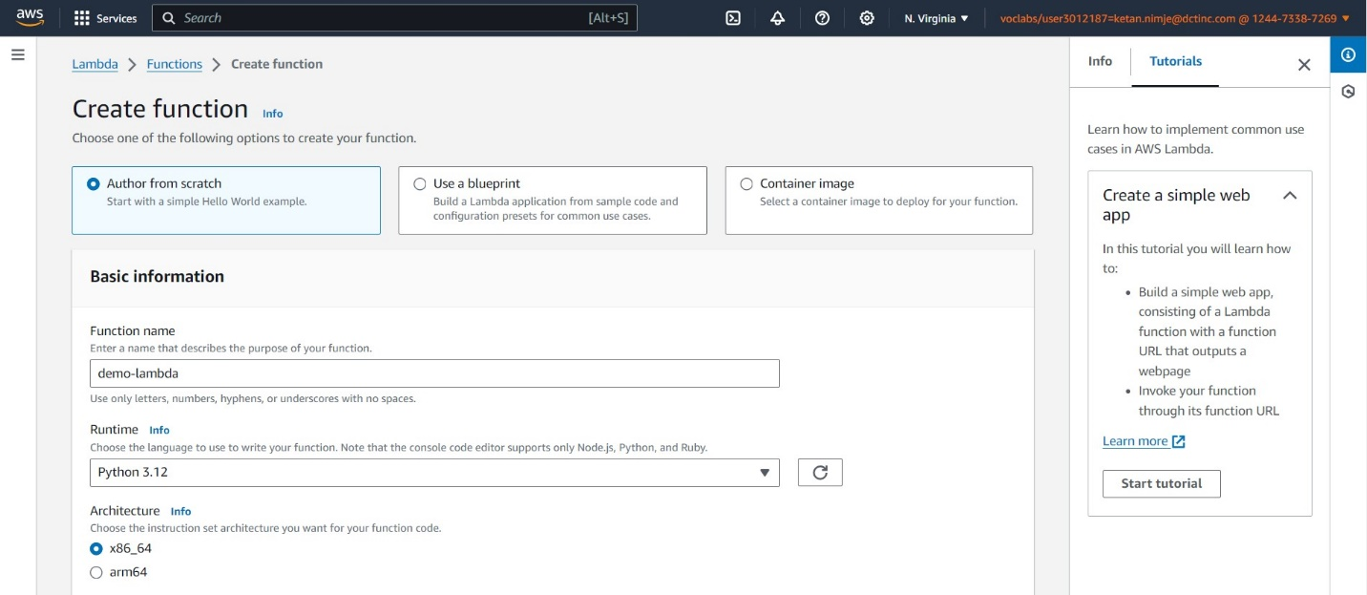

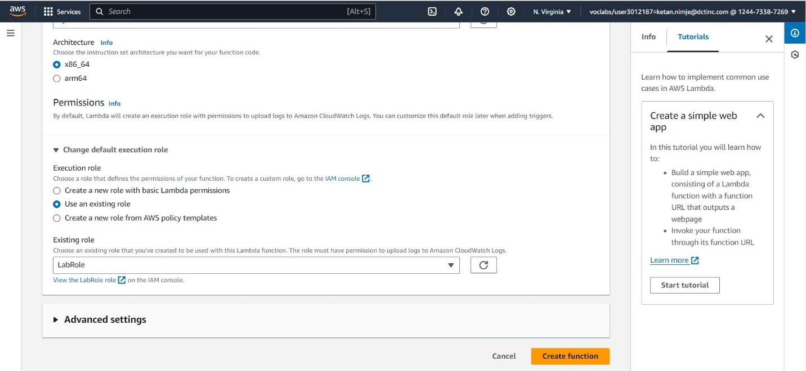

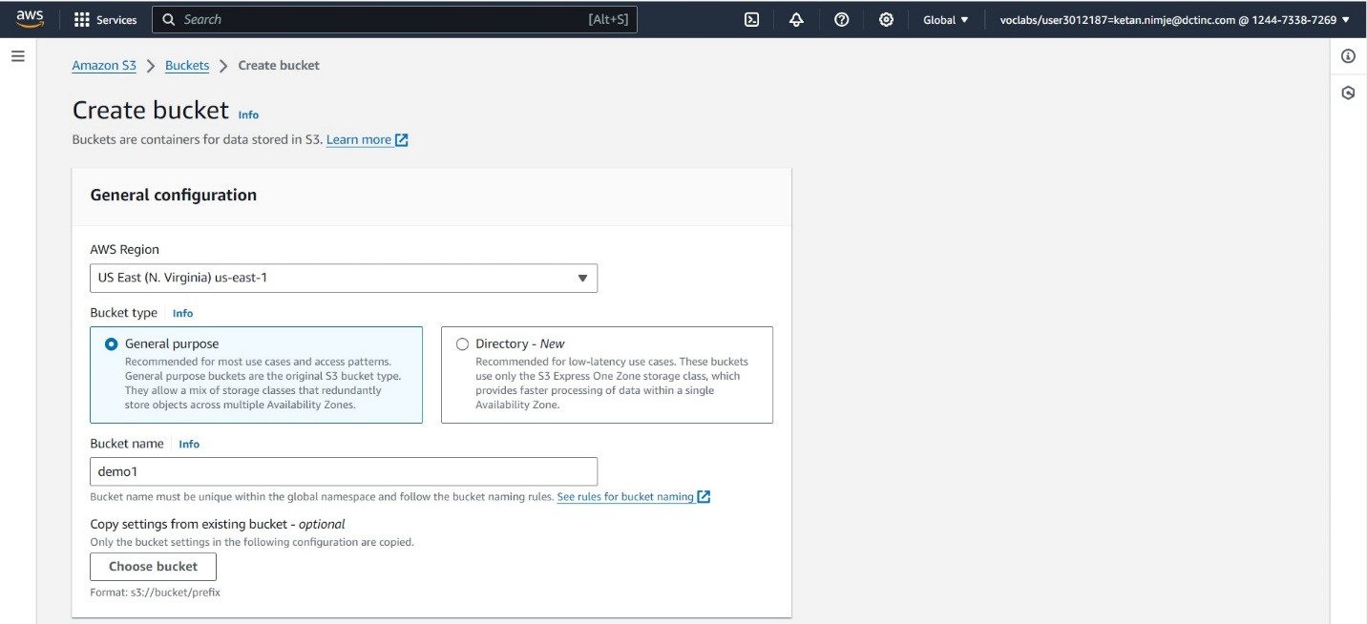

Then creating buckets for storage.

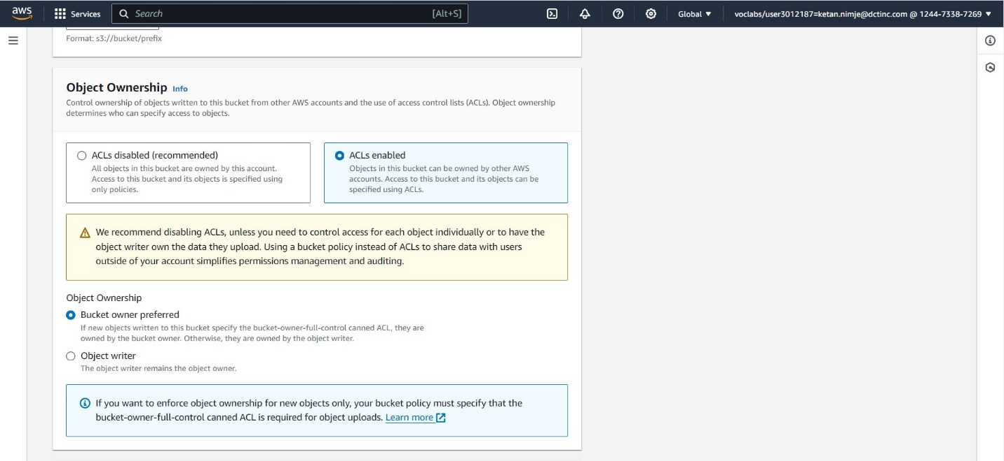

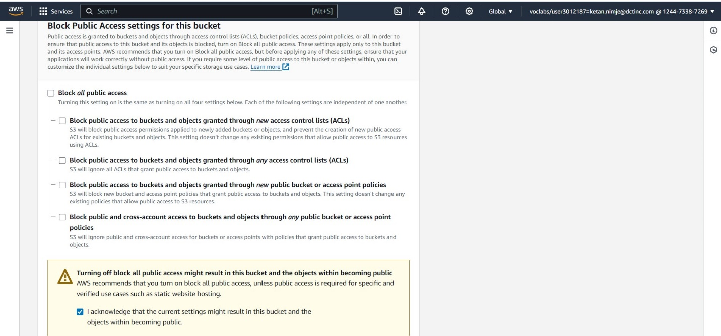

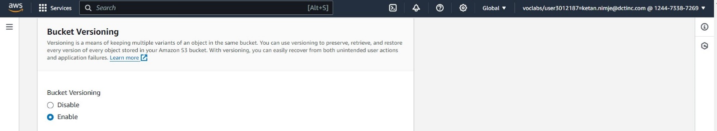

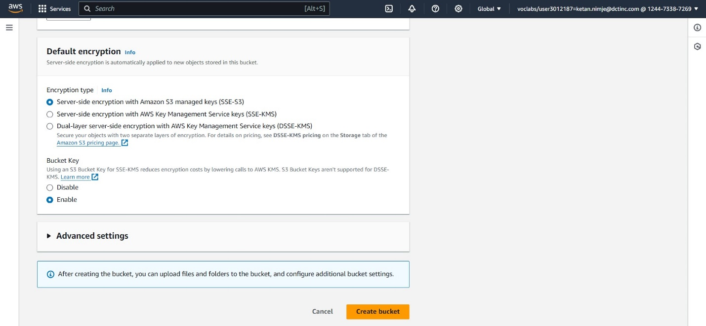

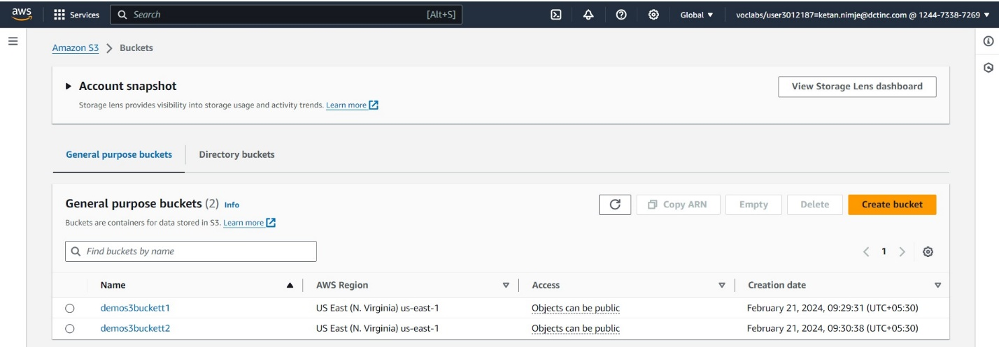

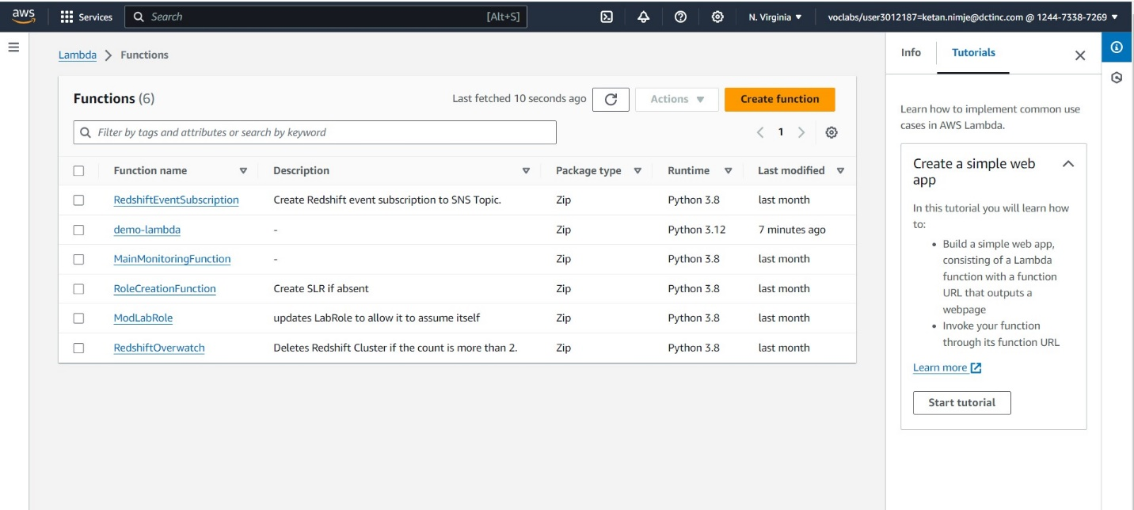

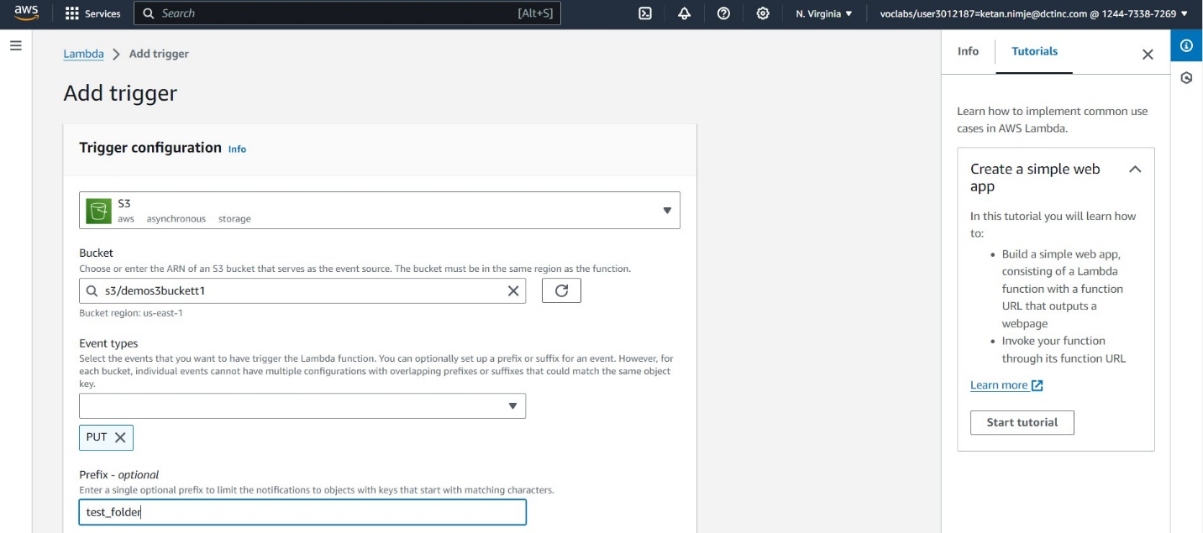

Adding S3 bucket as a trigger.

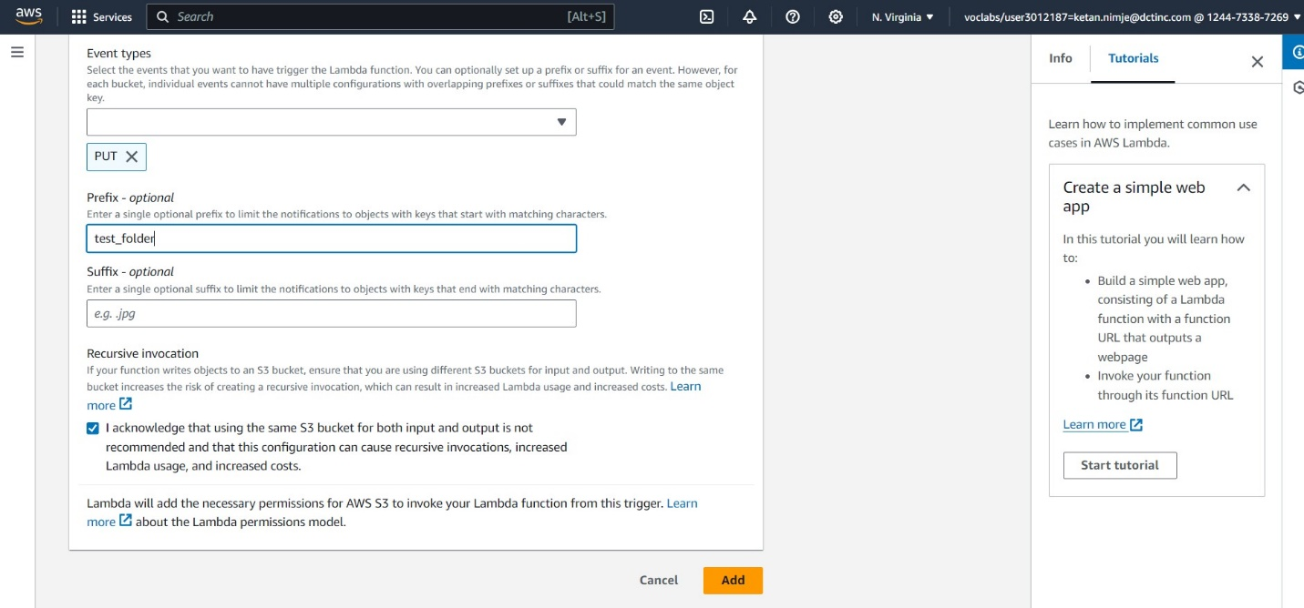

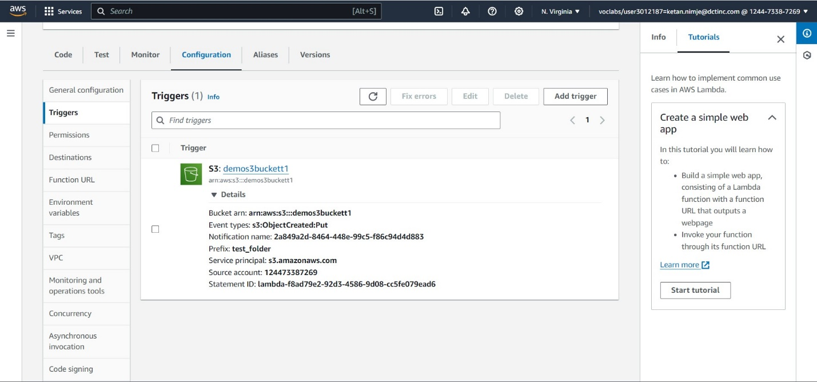

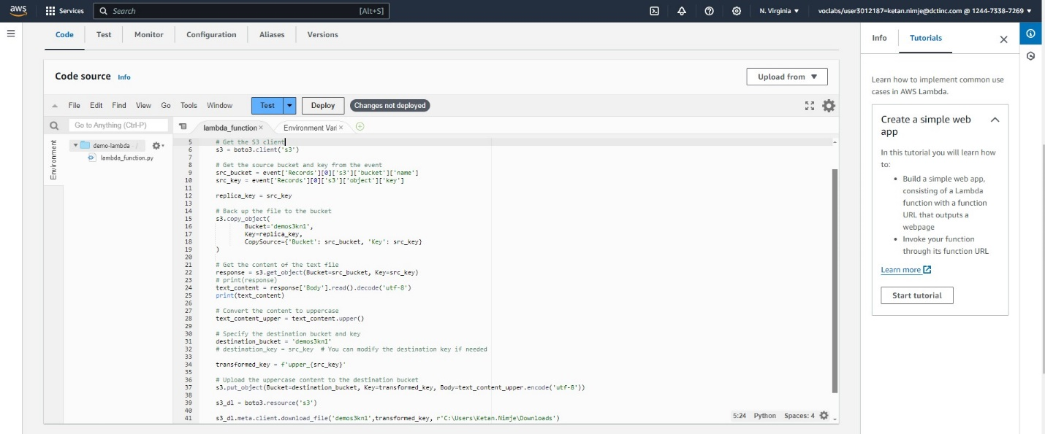

Code for triggering the lambda function when a file is uploaded into S3 bucket and then replicating the file into another bucket and creating a copy of same file in upper case in another bucket and then downloading the file into local machine.

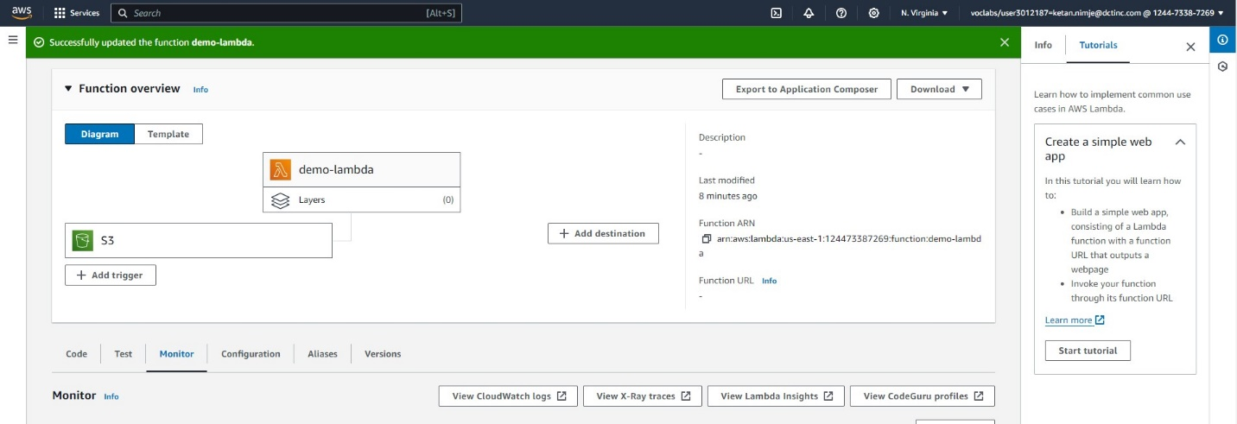

Viewing the cloud watch logs to check the status of code.

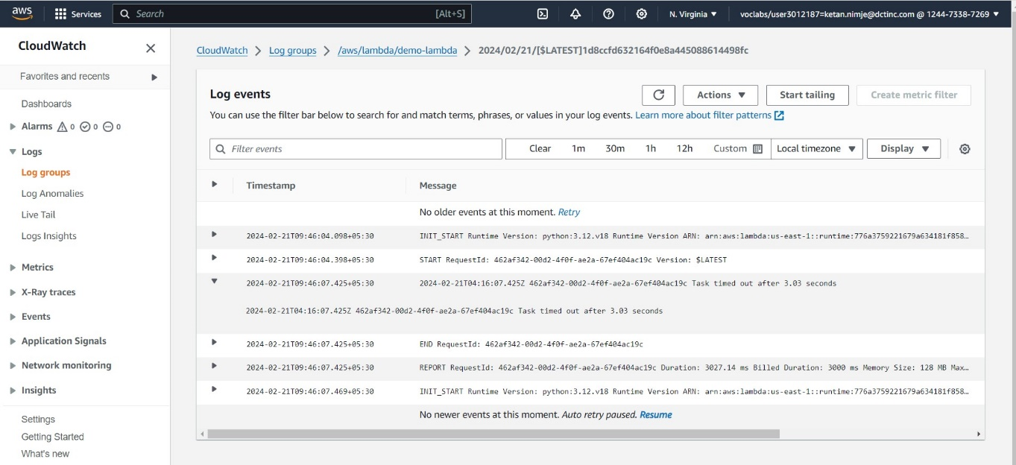

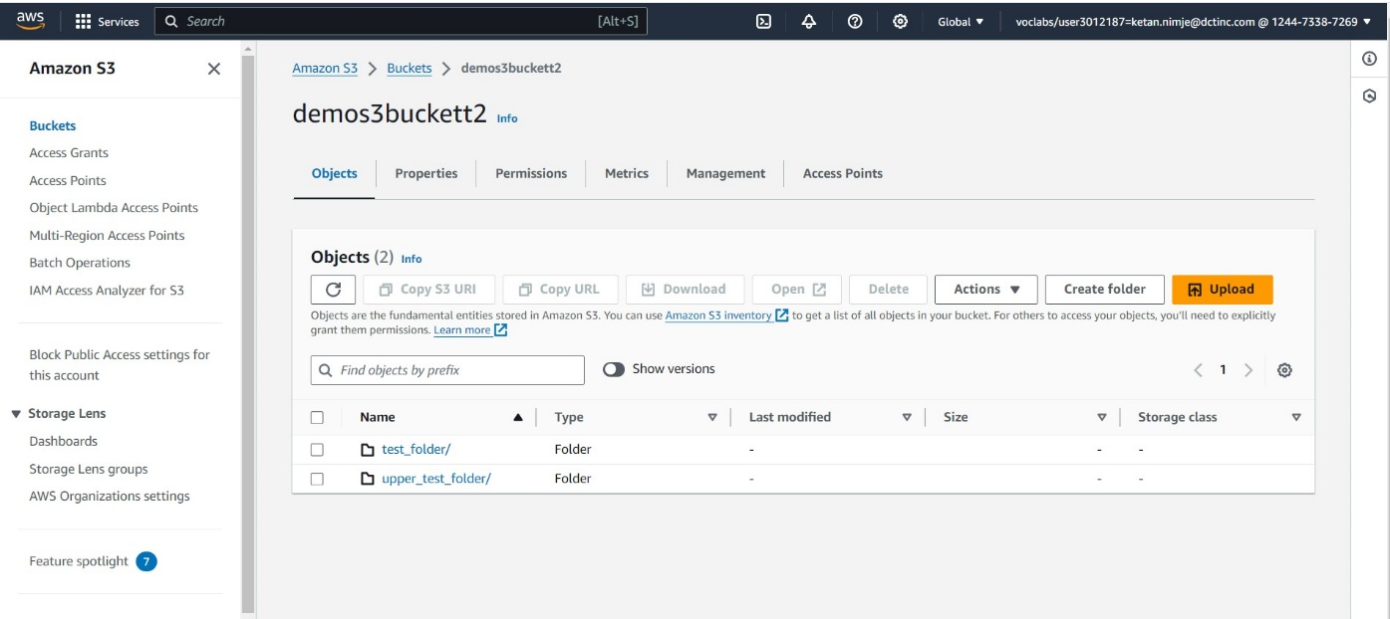

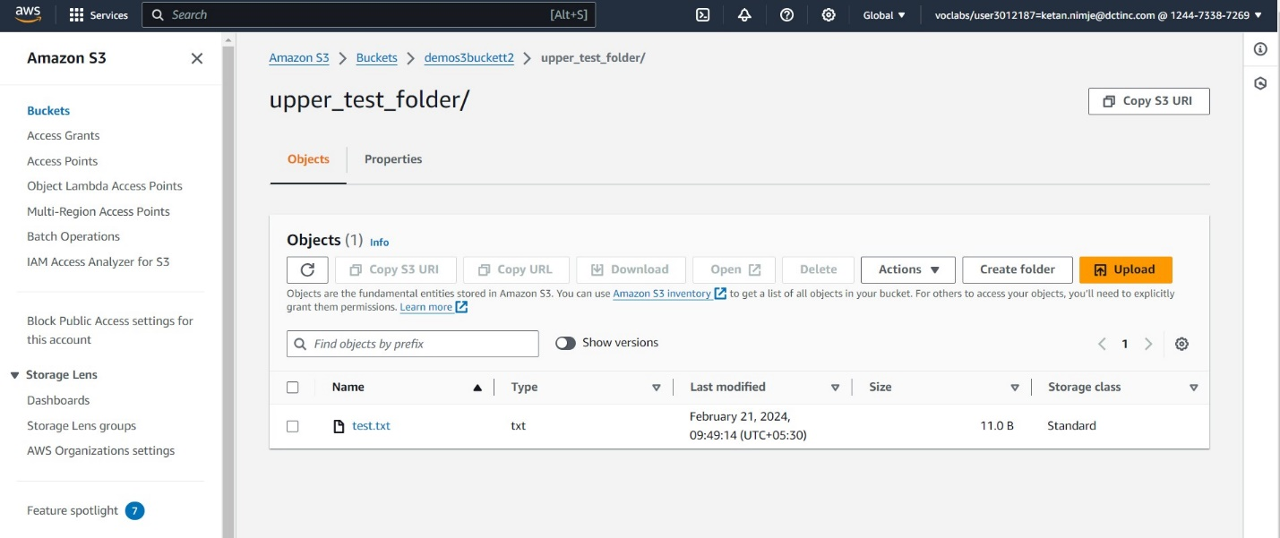

This is the desired output.